**Quadratic Equation** (2nd degree polynomial)

**Quadratic Function:**  *f* (*x*) = *ax*2 + *bx* + *c*, *a* ≠ 0, where *a*, *b*, and *c* are real numbers.

***Zeros:*** *Solutions* of *ax*2 + *bx* + *c* = 0.

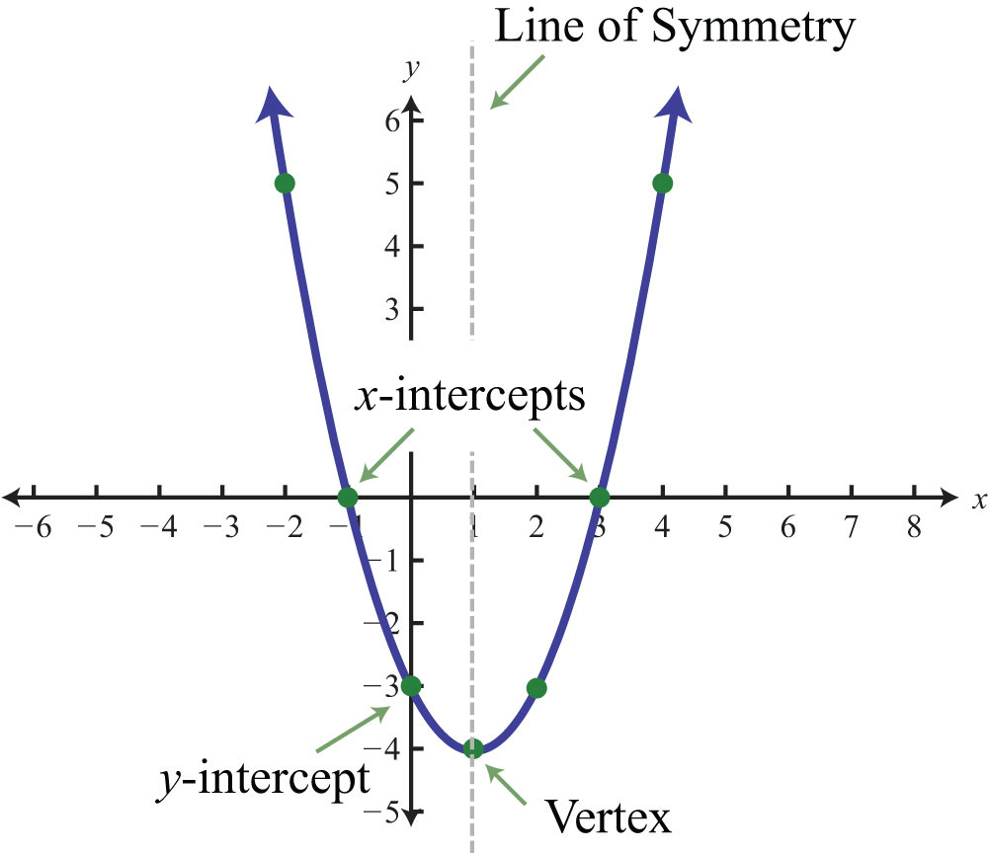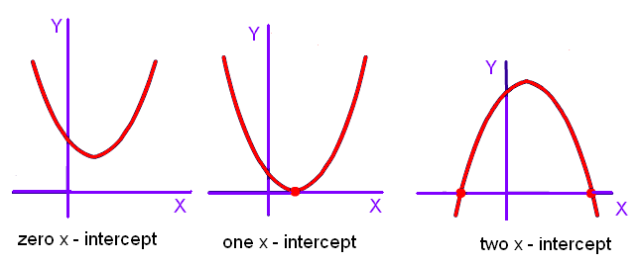

Every Parabola has:

1. **One** Vertex
2. **One** Y-intercept
3. **One** Line of Symmetry

BUT …

Some parabolas may differ when it comes to how many

x-intercepts they have.

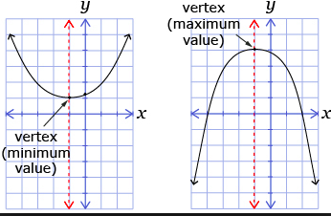

**Standard Form**

$$f\left(x\right)= ax^{2}+bx+c$$

|  |  |
| --- | --- |
| **Axis/Line Of Symmetry: $x=-\frac{b}{2a}$**  **Vertex:** The vertex of the parabola can be found by using the formula: $x= \frac{-b}{2a}$ and then substituting this x-value into the equation to find *y*.  **Y-intercept:**  * Plug in 0 for *x* and solve*  **X-intercept(s):**  * Set the function equal to zero and solve. |  |

**Example 1:** Sketch the graph of the following:

|  |  |
| --- | --- |
| 1. The parabola will open __________ 2. State the equation of the axis of symmetry ______ 3. State the vertex ___________ 4. The MAX – or - MIN value of the function is _______ 5. State the y-intercept ___________ 6. State the x-intercept(s) __________ | UNANNO01-08 blank grid.eps |

**Example 2:** Sketch the graph of the following:

|  |  |
| --- | --- |
| 1. The parabola will open __________ 2. State the equation of the axis of symmetry ______ 3. State the vertex ___________ 4. The MAX – or - MIN value of the   function is _______   1. State the y-intercept ___________ 2. State the x-intercept(s) __________ | UNANNO01-08 blank grid.eps |

**Example 3:** Sketch the graph of the following:

|  |  |
| --- | --- |
| 1. The parabola will open __________ 2. State the equation of the axis of symmetry_______ 3. State the vertex ___________ 4. The MAX – or - MIN value of the function is _______ 5. State the y-intercept ___________ 6. State the x-intercept(s) __________ *round to 2 decimal places | UNANNO01-08 blank grid.eps |

**Example 4:** (**Projectile Motion)**

A local rocketry club held a competition for the highest launch of a model rocket. Before launch, each rocket will be placed on a 2 foot-tall platform. The power produced by the motor, will then launch the rocket at an initial velocity of 200 ft/sec. Create a quadratic to model this situation. What is the vertex? Explain the meaning in the context of the problem.

**Projectile Motion Formula:**

$$h(t)=-16t^{2}+v_{0}t+p_{0}$$

$h=$ Height of the object at time $t$

$v_{0}=$ Initial velocity

$p_{0}=$ Initial position

**Example 5:** (**Revenue)**

A retailer who sells fashion boots estimates that by selling them for *x* dollars each, he will be able to sell 70 − *x* boots a week. Use the quadratic function *R*(*x*) = −*x*2 +70*x* to find the revenue received when the average selling price of a pair of fashion boots is *x*. Find the selling price that will give him the maximum revenue, and then find the amount of the maximum revenue.

**Example 6 (Geometry)**

A landscaper has enough stone to enclose a rectangular koi pond next to an existing garden wall of the Eagleman's’ house with 24 ft of stone wall. If the garden wall forms one side of the rectangle, what is the maximum area that the landscaper can enclose? What dimensions of the koi pond will yield this area?